Department of Microbiology

484 West 12th Avenue
Columbus, OH 43210-1292

Phone (614) 292-2301
Fax (614) 292-8120

November 30, 2010

Professor Larry Krissek
Chair, Arts and Sciences CCI
Re: Sociology BA and Criminology BA

Dear Professor Krissek:

At the November 24, 2010 meeting of the Mathematics and Social, Behavioral, and Natural Sciences CCI Subcommittee the semester conversion plans for the Sociology BA and Criminology BA programs, submitted by the Department of Sociology, were reviewed. The major and minor programs in Sociology had recently been revised and the semester conversion proposals for the two BA programs represent conversions with no significant change in their structures. The committee felt the proposals were substantial and covered the essential topics; however, we requested a few minor revisions for clarification. These included:

- We asked that the student learning goals be phrased in an active, student-center, voice.
- Clarification of the course numbering for Sociology 4191/3191.
- We asked that the curriculum map document indicate the levels (e.g. introductory or advanced, or other indicator) for the learning goals met by the individual courses.

Since these revisions were deemed minor, the subcommittee unanimously approved both proposals and we have submitted them for the next step in the approval process.

Sincerely,
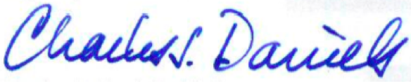

Charles J. Daniels, Ph.D.
Professor
Acting Subcommittee Chair for Nov. 24

